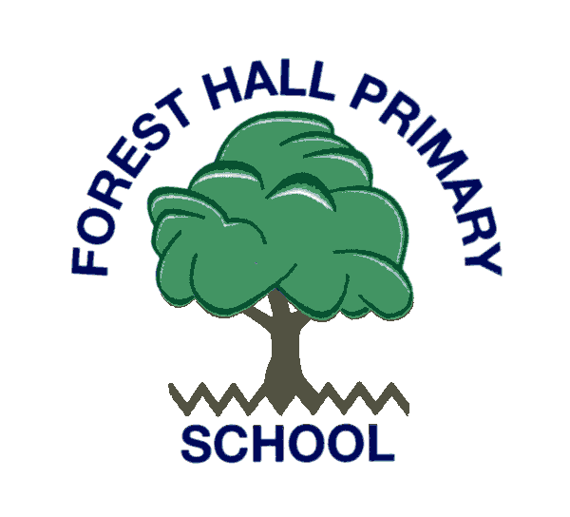

Forest Hall Primary School Nursery Application Form

Child’s Details
Surname
Forename
Date of Birth |  |  |  | Male/ Female
Home Address
Contact Number | Home: Mobile:
Email Address
Nationality |  |  | Language
Religion/ Belief Profile | None/ Christian/ Hindu/ Jewish/ Muslim/ Sikh Other:
Name of Person Completing Form
Relationship to Child
Siblings | Name | Date of Birth |  | School Attending
Admissions to Nursery
Children begin Nursery in September following their third birthday. We do accept children throughout the year once they have turned three provided there is space.
Our nursery is open mornings only Monday to Friday 8.45 – 11.45am.

30 hours
If you are eligible for 30 hours then this can be taken up at Forest Hall Primary School five days a week 11.45am- 3.15pm. We have 8 places available and children must bring their own packed lunch. 30 hour funding comes into place the term after a child turns three.
Please indicate below if you are entitled to 30 hours and/ or have a 30 hour code and the days you would intend on taking this up at Forest Hall Primary School.
30 hour code (if known) | Mon | Tue | Wed | Thu | Fri
If there is availability we also offer wraparound care at the cost of £15 per afternoon.

Over subscription criteria for 30 hours/ Wraparound
In the event that more children than we can cater for apply for our afternoon provision they will be prioritised in the following order:
- Children entitled to 30 hours who take this up at our setting 5 afternoons per week and are going into Reception the following September.
- Children entitled to 30 hours who take this up at our setting 5 afternoons per week and are remaining in nursery the following September.
- Children entitled to 30 hours who will take this up at our setting for 1-5 afternoons per week.
- Children who pay for wraparound care for 5 afternoons per week every week.
- Children who pay from wraparound care for 1-5 afternoons on a weekly basis.

Signed ________________________________ Date ______________________________

Email: office@foresthallprimary.co.uk Tel: 0191 300 9341
Forest Hall Primary School, Delaval Road, Forest Hall, NE12 9BA

